**SUPPLEMENTARY MATERIALS**

**Mathematical Analysis of Robustness of Oscillations in Models**

**of the Mammalian Circadian Clock**

X. Yao, B.L. Heidebrecht, J. Chen & J.J. Tyson

21 January 2022

Table of Contents

Table S1. Definitions of the dynamical variables in the models 2

Table S2. Definitions of the dimensionless parameters in the models 3

Goodwin’s model 4

Kim & Forger’s extended models 6

Non-dimensionalization of the modified Kim-Forger equations 7

Phase dispersion turns bulk oscillatory trajectory perfectly sinusoidal 8

Deriving the rate laws for *Per* transcription 9

Parameter optimization for models with saturating degradation of nuclear PER 11

Period dependence on fold-changes in *Bmal1* and *Per* expression 22

Supplementary references 25

# Table S1. Definitions of the dynamical variables in the models

|  |  |  |
| --- | --- | --- |
| Dimensionless Variable | Definition* | Physical Meaning |
| *t* |  |  |
| *M* |  | *Per* mRNA |
| *Pi* |  | Cytoplasmic PER species |
| *P* |  | Nuclear PER |
| *A* |  | Nuclear BMAL |
| *R* |  | Nuclear ROR |
| *V* |  | Nuclear REV-ERB |

*All ‘hatted’ variables and parameters carry units of concentration (nM) and time (h). We have assumed that all the first-order rate constants for loss of mRNA and cytoplasmic PER species are identical: .

# Table S2. Definitions of the dimensionless parameters in the models

|  |  |  |
| --- | --- | --- |
| Dimensionless Parameter | Definition | Meaning |
| *K*d | 1 | Dissociation constant of the PER:BMAL complex |
| *K*A |  | Dissociation constant of the BMAL:Ebox complex |
| *K*m |  | Michaelis constant for the degradation of nuclear PER |
| *β*max |  | Maximum rate of degradation of nuclear PER |
| *α* |  | Maximum rate of transcription of *Per* gene |
| *A*T |  | Total BMAL concentration (bound + unbound) |
| *A*MAX |  | Maximum concentration of BMAL |
| *V*MAX |  | Maximum concentration of REV-ERB |
| *R*MAX |  | Maximum concentration of ROR |
| *δ* |  | Rate constant for turnover of BMAL, REV-ERB and ROR |

# Goodwin’s model

To account for observations of periodic enzyme synthesis in bacteria [1], Brian Goodwin [2, 3] presented the following model for the periodic synthesis of an enzyme Y from its mRNA X, where mRNA synthesis is inhibited by a repressor Z that is the product of the catalytic action of Y:

|  |  |  |  |
| --- | --- | --- | --- |
|  |  |  | (S1) |
|  |  |  | (S2) |
|  |  |  | (S3) |

In Eq. (S1), the factor is the probability that the promoter region of the gene encoding X is not bound to Z, its repressor, and *α*1 is the maximum rate of synthesis of X by the gene. The other terms in these equations correspond to first-order rate laws for production and removal of X, Y and Z. In this tableau, Goodwin’s equations are written in two equivalent forms. On the left, the equations are written in terms of the original dimensional variables: concentrations *X*, *Y* and *Z* (nM) and time *T* (h); on the right, in terms of the ‘dimensionless’ variables , , , dimensionless time , and a dimensionless parameter . In deriving these dimensionless equations, we have assumed (as have all authors in the past) that , which serves to maximize the oscillatory potential of the model [4, 5]. In Goodwin’s version of a three-component negative-feedback loop, the repression of gene transcription by Z is modeled by a Hill function with exponent *p*. Underlying this function is the supposition that the gene encoding X is turned off when *p* molecules of Z bind cooperatively to its promoter region (or, equivalently, when *p* molecules of Z bind cooperatively to an activator of gene transcription and shut it off).

A problem with Goodwin’s model. J.S. Griffith [6] was first to point out that Goodwin’s equations (S1)-(S3) admit oscillatory solutions only if , a very restrictive condition, because in experimental studies it is rare that more than 3 or 4 protein molecules bind cooperatively to DNA regulatory sequences [7]. This condition becomes even more restrictive if [4].

One solution: a longer feedback loop. The restriction *p* > 8 can be ameliorated by lengthening the feedback loop: if *n* = number of variables in the feedback loop, then the necessary condition for oscillations becomes . For example, for *n* = 8, the condition is *p* > 1.88. Longer loops (*n* > 3) correspond to inserting more than one intermediate (say, Y0, Y1, …, Y*n*−3) between X (mRNA) and Z (feedback component). This is quite reasonable, considering that PER protein has multiple phosphorylation sites [8]. Each intermediate, Y*j*, then denotes cytoplasmic PER phosphorylated on *j* sites, *j* = 0, 1, …, *J*. Eventually, the fully phosphorylated form, Y*J*, is transported into the nucleus and becomes Z. In this case, Goodwin’s dimensionless differential equations become Eqs. (S4)-(S7).

|  |  |  |
| --- | --- | --- |
|  |  | (S4) |
|  |  | (S5) |
|  |  | (S6) |
|  |  | (S7) |

Exactly the same equations can be derived by assuming a distributed time lag between *x* and *z* [9]:

|  |  |  |
| --- | --- | --- |
|  |  | (S8) |

Introduce the new variables,

|  |  |  |
| --- | --- | --- |
|  |  | (S9) |

For *j* = 0, we have Eq. (S5) for *dy*0/*dt*. For *j* ≥ 1, *Gj*(0) = 0 and d*Gj*(*u*)/d*u* = *Gj*−1(*u*)− *Gj*(*u*); so we have Eq. (S6) for *dy*j/*dt* for and Eq. (S7) for *dz*/*dt*.

A second solution: Michaelis-Menten degradation of Z. In 1982 Bliss, Painter and Marr [10] proposed to replace the first-order degradation of Z, by a Michaelis-Menten rate law, where is the ‘Michaelis’ constant of the enzyme-catalyzed reaction and is the ‘*V*max’ of the reaction. With this change, the Goodwin model can exhibit limit cycle oscillations even for *p* = 1 [10]. The substitution of Michaelis-Menten rate laws for the first-order kinetic terms in Eqs. (S1)-(S3) has been exploited by many authors [11-13] to increase the robustness of their models of circadian rhythms.

# Kim & Forger’s extended models

In addition to the SNF model, Kim & Forger proposed two extended models, in which the core negative feedback loop involving PER and BMAL1 is supplemented with (either) an additional negative feedback from REV-ERB on transcription of the *Bmal1* gene (Figure 2b) (or) an additional positive feedback from ROR on transcription of the *Bmal1* gene (Figure 2c) [14]. Both extended models include the ODEs of the core SNF model.

Kim-Forger NNF Model. Equations (1)-(4) of the main text, plus

|  |  |  |
| --- | --- | --- |
|  |  | (S10) |
|  |  | (S11) |

where *V* is the (scaled) concentration of REV-ERB, *V*maxis the maximum achievable concentration of REV-ERB, *V*o is the REV-ERB concentration that would result in *A*T = 1 at steady state, and *δ* is a rate constant that sets the time scale for the feedback loop.

Kim-Forger PNF Model. Equations (1)-(4) of the main text, plus

|  |  |  |
| --- | --- | --- |
|  |  | (S12) |
|  |  | (S13) |

where *R* is the (scaled) concentration of ROR, and *R*max, *R*o and *δ* are defined similarly as in the NNF equations. For simulations of the NNF and PNF models, Kim & Forger chose *δ* = 0.2, *V*max = *R*max = 5, and they adjusted *V*o and *R*o to make the NNF and PNF models have the same average activator concentration, <*A*T>, as the SNF model.

# Non-dimensionalization of the modified Kim-Forger equations

The models presented in this paper, as well as Kim and Forger’s original models, were cast in non-dimensional form before simulation and analysis. For example, we show how to non-dimensionalize the SNF(1M8) model, and the other variations use the same non-dimensionalization factors for the variables.

|  |  |
| --- | --- |
| Dimensional Equations | Non-dimensional Equations |
|  |  |
|  |  |
|  |  |
|  |  |
|  |  |
|  |  |
|  |  |
|  |  |
|  |  |

where we have already set , because this constraint makes oscillations most likely. Species P1 … P6 represent both mRNA species (say, P1 = mature mRNA in nucleus, P2 = mRNA in cytoplasm) and PER proteins in the cytoplasm (say, P3 = unphosphorylated PER, P4 = monophosphorylated PER, etc.), and P = nuclear PER. The purpose of non-dimensionalization is to ‘scale away’ as many of the kinetic parameters as possible, to reduce the dimensionality of the space of independent parameters. To this end, we make the following change of variables from ‘hat-wearing’ variables (carrying physical units) to their respective dimensionless versions:

, , , …, , ,

The dimensionless ODEs (above right) are governed by five dimensionless parameters:

, , , , and

# Phase dispersion turns bulk oscillatory trajectory perfectly sinusoidal

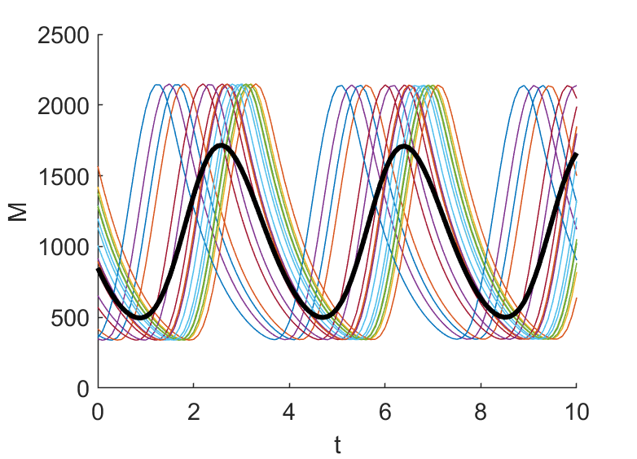

**Figure S1.** **Bulk average of asymmetric oscillatory trajectories appears sinusoidal**. Thin colored lines: *M*(*t*) trajectory in Figure 3 with a random shift in phase. The random phase was drawn from a normal distribution with zero mean and standard deviation of 0.5 time unit (~ 1/10 of the oscillation period). Thick black line: average of the colored trajectories. Skewness of a single colored trajectory and the average trajectory is 0.42 and 0.17, respectively. Skewness is defined as [15].

# Deriving the rate laws for *Per* transcription

BMAL:CLOCK binds to many E-box sequences throughout the mammalian genome, and PER:CRY binds to both free and E-box-bound BMAL:CLOCK complexes. Let E*i*, *i* = 1, …, Ω, denote all the E-box sequences that bind all four proteins BMAL, CLOCK, PER and CRY, where Ω ≈ 1500 according to ChIP-seq data [16]. The total concentrations of BMAL:CLOCK (A) and PER:CRY (P) dimers are:

|  |  |  |  |  |
| --- | --- | --- | --- | --- |
|  | |  | | (S14) |
|  |  | | (S15) | |

We are assuming that the synthesis and degradation of proteins are much slower reactions than the association and dissociations of proteins in a complex, so the total amounts of A and P in the system can be treated as constants on the time scale of the binding and unbinding reactions.

Because the total number of E-boxes (~1500) is considerably less than the total number of BMAL:CLOCK and PER:CRY complexes (~25,000 and ~30,000, respectively [17]), we can reasonably neglect the E-box-bound forms of the protein complexes, and assume that

|  |  |  |
| --- | --- | --- |
|  |  | (S16) |
|  |  | (S17) |

To derive an expression for the rate of *Per* transcription, we need to estimate the fraction of E-boxes bound to BMAL:CLOCK but not to PER:CRY, i.e., [A:E*p*]/[E*p*]T, where *p* is the index corresponding to E-boxes driving *Per* gene expression. To this end, we consider the equilibrium binding reactions:

|  |  |  |
| --- | --- | --- |
|  |  | (S18) |
|  |  | (S19) |
|  |  | (S20) |
|  |  | (S21) |

The equilibrium dissociation constants of Reactions (S18)-(S21) are defined by

|  |  |  |
| --- | --- | --- |
|  |  | (S22) |

The principle of detailed balance at equilibrium requires that

|  |  |  |
| --- | --- | --- |
|  |  | (S23) |

That is, the dissociation constants for Reactions (S13)-(S16) satisfy

|  |  |  |
| --- | --- | --- |
|  |  | (S24) |

Taking Eq. (S24) into account, we are left with only three independent chemical equilibrium equations. One of these equations is

|  |  |  |
| --- | --- | --- |
|  |  | (S25) |

which can be solved for the unknown concentration of A:P,

|  |  |  |
| --- | --- | --- |
|  |  | (S26) |

Meanwhile, the total number of *Per* E-boxes, [E*p*]T = [E*p*] + [A:E*p*] + [P:A:E*p*], can be written as:

|  |  |  |
| --- | --- | --- |
|  |  | (S27) |

which can be rearranged to give the probability that a *Per* gene is being transcribed:

|  |  |  |
| --- | --- | --- |
|  |  | (S28) |

Plugging the definition of *K*dAP1 (Eq. (S22)) into Eq. (S28) yields

|  |  |  |
| --- | --- | --- |
|  |  | (S29) |

First Case. PER:CRY binds equally strongly to free- and E-box-bound BMAL:CLOCK, i.e.,

|  |  |  |
| --- | --- | --- |
|  |  | (S30) |

In this case, Eq. (S29) becomes

|  |  |  |
| --- | --- | --- |
|  |  | (S31) |

Plugging Eq. (S16) into Eq. (S31) yields Rate Law 1:

|  |  |  |
| --- | --- | --- |
|  |  | (S32) |

Second Case. PER:CRY binds equally strongly to free- and E-box-bound BMAL:CLOCK, Eq. (S30) (First Case above), and at the same time, BMAL:CLOCK saturates the *Per* E-box, i.e.,

|  |  |  |
| --- | --- | --- |
|  |  | (S33) |

In this case, Eq. (S32) becomes Rate Law 0 in the original Kim-Forger model:

|  |  |  |
| --- | --- | --- |
|  |  | (S34) |

Third Case. BMAL:CLOCK cannot or can hardly bind PER:CRY and E-box simultaneously, i.e.,

|  |  |  |
| --- | --- | --- |
|  |  | (S35) |

In this case, Eq. (S29) gives rise to Rate Law 2:

|  |  |  |
| --- | --- | --- |
|  |  | (S36) |

Electron microscopy studies by Aryal et al. have shown that PER:CRY::BMAL:CLOCK complexes bind to E-boxes [18], indicating that rate laws 0 and 1 are to be preferred to rate law 2.

# Parameter optimization for models with saturating degradation of nuclear PER

We used MATLAB’s simulated annealing method (‘simulannealbnd’) to optimize the parameters of SNF(0M8), SNF(1M8), NNF(1M8) and PNF(1M8) models within physiologically reasonable ranges, as indicated below. The optimization criteria we used for each model and the corresponding cost functions are also given below. The model outputs used in the cost functions were obtained by simulating the model with the corresponding parameter set. Specifically, we used MATLAB’s stiff ODE solver (‘ode15s’) to generate simulated trajectories with final time = 2,000. For each trajectory we analyzed the segment between times 1,800 and 2,000 to obtain the output quantities of interest, such as period, max(*P*tot) and amp(*P*tot). We performed simulated annealing multiple times, starting from 1,100 random initial guesses of parameter values generated by the Latin hypercube method applied to log-uniform distributions of the parameters over the same ranges that bound the optimization. In a small fraction of cases for each model, the optimization aborted and generated no results. We present below the most noteworthy patterns based on all the results we obtained.

Optimization of SNF(0M8)

Criteria:

1. max(*P*tot) is minimized, in order to select parameters sets with the largest values of .
2. Relative amplitude of *P*tot > 0.5, in order to select parameter sets that generate robust oscillation.

Cost function:

|  |  |  |
| --- | --- | --- |
|  |  | (S37) |

The second criterion was implemented in a complicated form to penalize oscillations of small amplitude and avoid getting stuck with non-oscillating parameters.

Range of parameters:

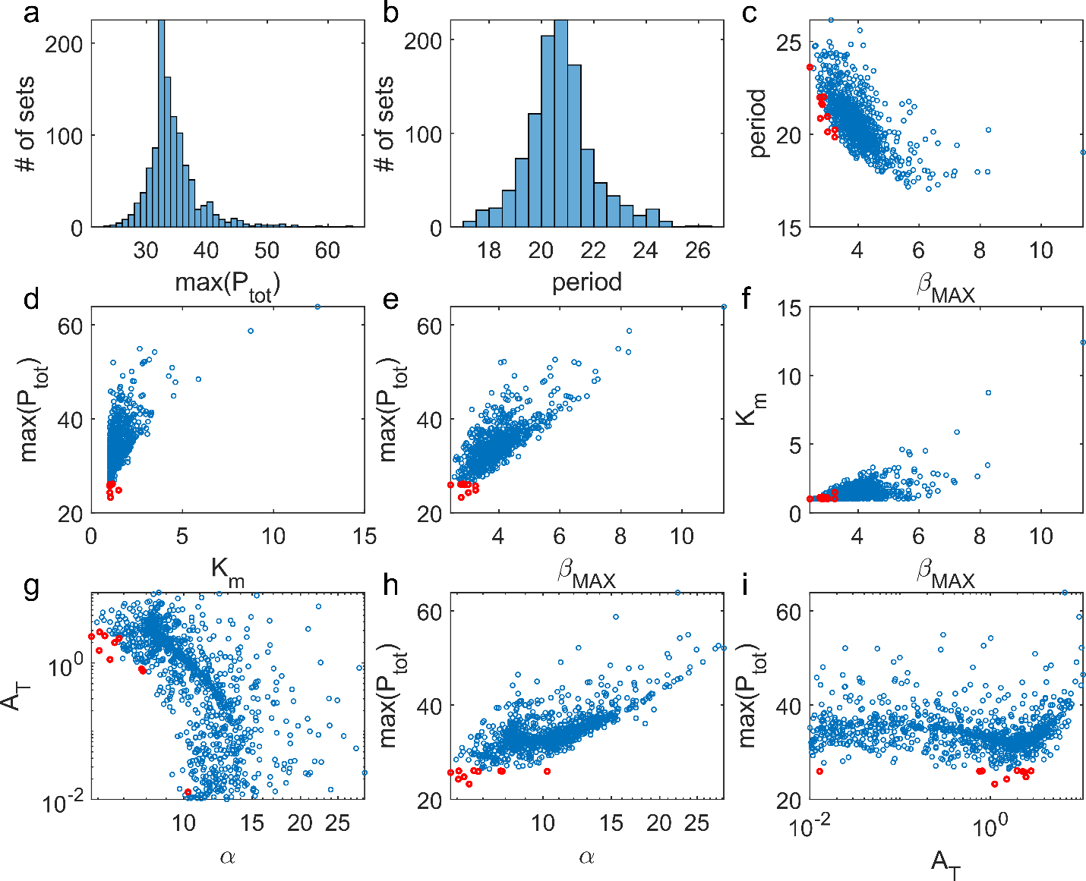

**Figure S2.** **Notable patterns in optimization results for SNF(0M8)**. Blue: 1100 parameter sets obtained through optimization are plotted in each panel. Red: top 10 parameter sets, i.e., those with the smallest values of max(*P*tot).

Main findings (see Figure S2):

1. max(*P*tot) = 34.3 ± 4.0 (Figure S2a). Period = 20.7 ± 1.3 (Figure S2b).
2. Period is strongly negatively correlated with *β*max(Figure S2c), but not other parameters (not shown). This is not surprising, since smaller values of *β*max mean a longer time delay for degrading nuclear PER and reinstituting *Per* gene transcription. The top 10 sets generate intermediate periods between 20 and 24 (Figure S2c).
3. Low max(*P*tot) requires low *K*m and *β*max (Figure S2d-f). Lower values in both parameters slow down PER degradation, introduce time delay and increase robustness of oscillation (allowing oscillation to happen for larger values of ).
4. *α* and *A*T are negatively correlated (Figure S2g), which is opposite to the trend shown in Fig. 6a for SNF(0L8), although we are comparing different types of diagrams.
5. max(*P*tot) is positively correlated to *α* (Figure S2h, as expected) but not to *A*T (Figure S2i).
6. The range of optimal values of *α* (1—30) is much smaller than the range of *A*T (0.01—10) (Figure S2g). Because its rate of degradation saturates at high concentration, the level of PER in the nucleus tends to stay high for an extended period of time, which places a constraint on the rate of expression of the *Per* gene.

Optimization of SNF(1M8)

Criteria:

1. max(*P*tot) is minimized, in order to select parameters sets with the largest values of .
2. Relative amplitude of *P*tot > 0.5, in order to select parameter sets that generate robust oscillation.

Cost function:

|  |  |  |
| --- | --- | --- |
|  |  | (S37) |

The second criterion was implemented in a complicated form to penalize oscillations of small amplitude and avoid getting stuck with non-oscillating parameters.

Range of parameters:

Main findings (see Figure S3):

1. max(*P*tot) = 32.3 ± 3.5 (Figure S3a). Period = 20.7 ± 1.1 (Figure S3b). The distributions are quite similar to SNF(0M8) in Figure S2a, b.
2. Period is strongly negatively correlated with *β*max(Figure S3c), but not other parameters. This is not surprising, since smaller values of *β*max mean a longer time delay for degrading nuclear PER and reinstituting *Per* gene transcription. The top 10 sets generate intermediate periods between 20 and 23 (Figure S3c).
3. Low max(*P*tot) requires low *K*m and *β*max (Figure S3d-f). Lower values in both parameters slow down PER degradation, introduce time delay and increase robustness of oscillation (allowing oscillation to happen for larger values of ).
4. *α* and *A*T are negatively correlated (Figure S3g). This result is opposite to the trend in L models (see Fig. 6b, although we are comparing different types of diagrams).
5. *A*T must be greater than ~ *K*A/100 (Figure S3h). The top 10 sets are concentrated in a narrow range of *A*T between 1 and 5 (Figure S3h).
6. *α* and *K*A are positively correlated, and *α* must be greater than (Figure S3i), presumably to have sufficiently rapid transcription of *Per* gene as *K*A increases. Also, for small values of *A*T, *α* can be much larger in SNF(1M8) compared to SNF(0M8), because the rate of *Per* transcription is more restricted at low *A*T in rate law 1 compared to rate law 0.

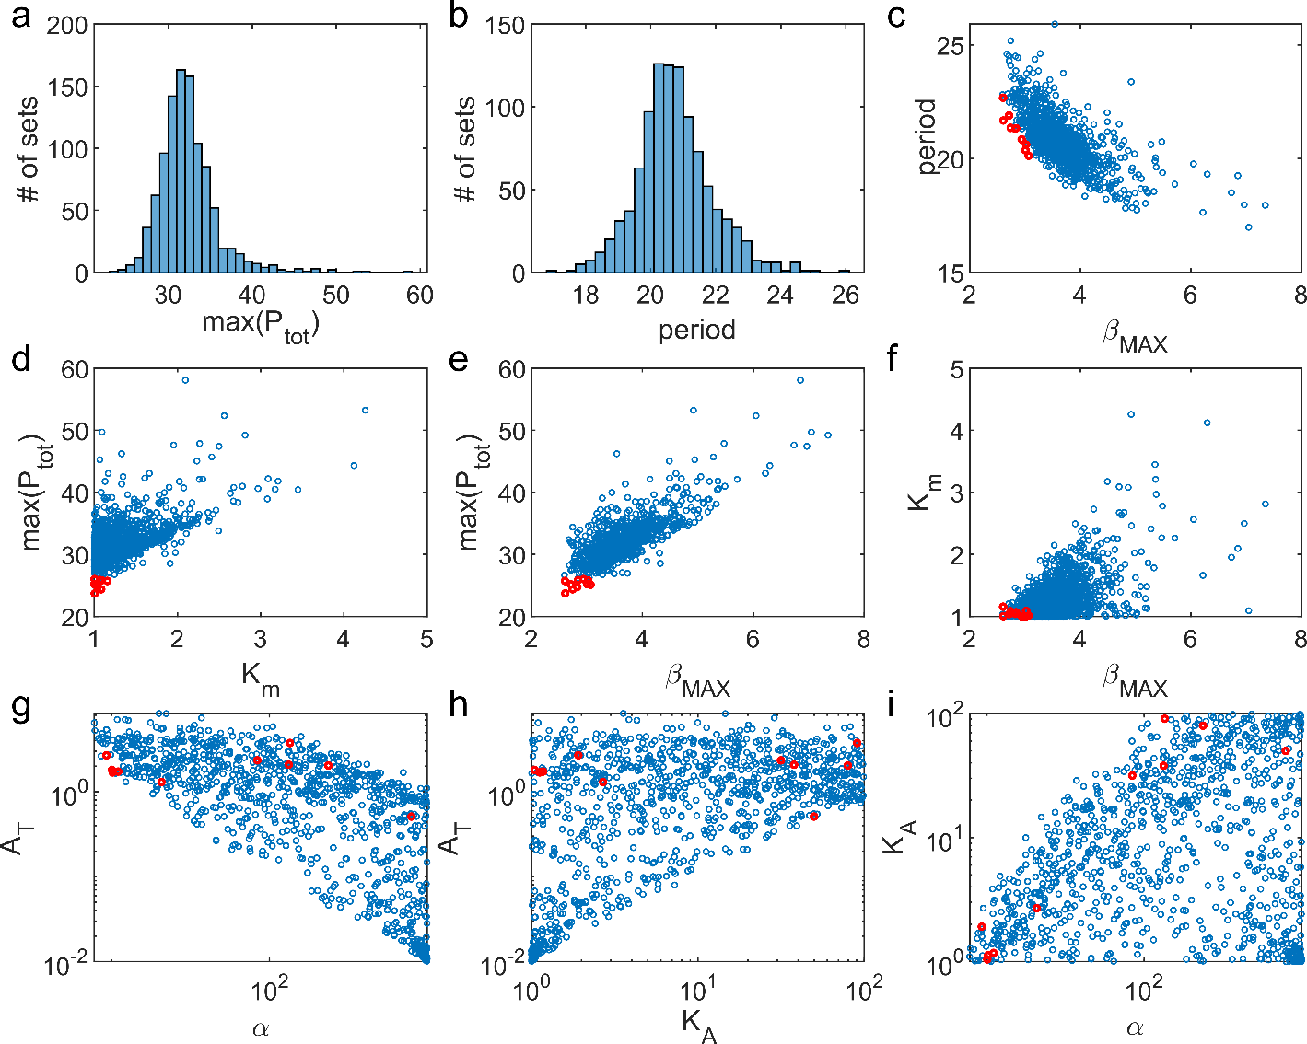

**Figure S3.** **Notable patterns in optimization results for SNF(1M8)**. Blue: 1013 parameter sets obtained through optimization are plotted in each panel. Red: top 10 parameter sets, i.e., those with the smallest values of max(*P*tot).

Optimization of NNF(1M8)

Criteria:

1. max(*P*tot) is minimized in order to select parameters sets with the largest values of .
2. Relative amplitude of *P*tot > 0.5, in order to select parameter sets that generate robust oscillation.
3. Relative amplitude of *A*T > 0.2, because experimental data show ~20% amplitude in BMAL oscillation [19].
4. max(*V*) < 10, in order that , the equilibrium dissociation constant for REV-ERB binding to the promotor of the *Bmal* gene, is not too small.
5. max(*A*T) / max(*P*tot) as close to 1 as possible; this criterion is introduced because without it we often ended up with parameter sets for which max(*A*T) / max(*P*tot) is very small. However, experimental data show that the peak levels of PER and BMAL are comparable [19].

Cost function:

|  |  |  |
| --- | --- | --- |
|  |  | (S38) |

Criteria 2 and 3 above were implemented with functions taking a form similar to Criterion 2 in the SNF model.

Range of parameters:

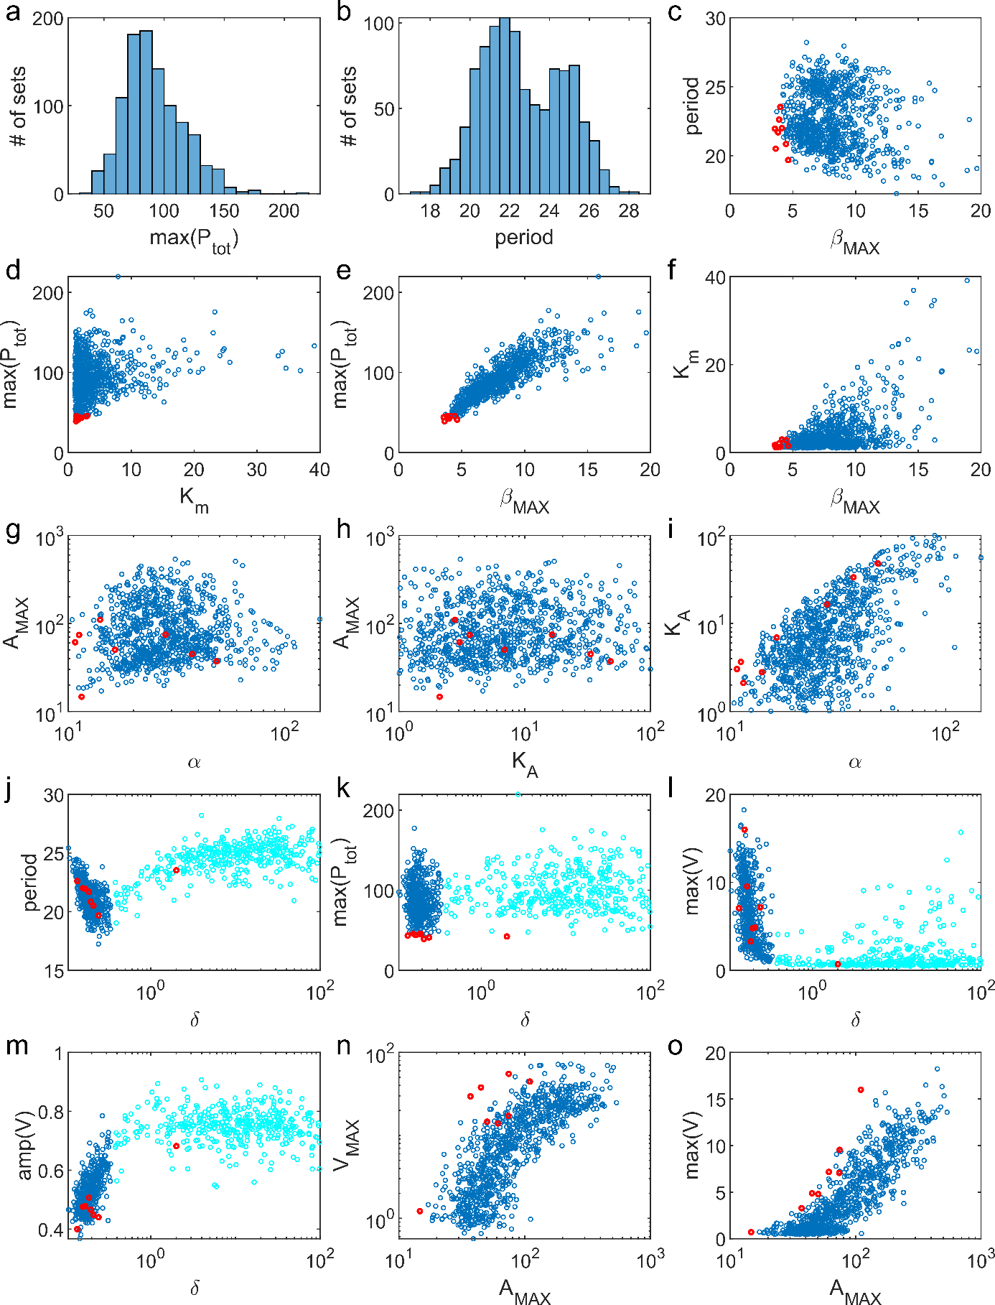

**Figure S4.** **Notable patterns in optimization results for NNF(1M8)**. Blue: 1011 parameter sets obtained through optimization are plotted in each panel. Cyan in (j)-(m): 423 parameter sets with *δ* > 0.35. (The *δ* > 0.35 sets are not highlighted in the other panels because they are mixed with the *δ* < 0.35 group.) Red: top 10 parameter sets (with smallest values of max(*P*tot)).

Main findings:

1. max(*P*tot) = 91.7 ± 24.5 (Figure S4a). Period = 22.7 ± 2.1 (bimodal, Figure S4b).
2. Period is not strongly correlated with *β*max (Figure S4c), which is surprising. But it is strongly correlated with *δ* (Figure S4j).
3. Low max(*P*tot) requires low *K*m and *β*max (Figure S4d-f), but not as strongly as in SNF (Figure S3d-f). Note that Figure S4d-f and Figure S3d-f have very different axis ranges.
4. Unlike SNF models, *α* and *A*MAX are no longer correlated (Figure S4g). Neither are *A*MAX and *K*A (Figure S4h). But *α* and *K*A remain positively correlated (Figure S4i).
5. With regard to the time-scale parameter, *δ*, there appear to be two clusters, separated by a value of ~0.35 (Figure S4j, k). The majority of top sets (red) have *δ* < 0.35. In comparison to the *δ* < 0.35 cluster, the *δ* > 0.35 cluster is associated with *V*(*t*) with smaller maximum values (Figure S4l) yet larger amplitudes (Figure S4m).
6. *A*MAX is positively correlated with *V*MAX (Figure S4n). Top 10 sets are associated with nearly the highest ratio of *V*MAX to *A*MAX. Consistently, these top sets generate the highest max(*V*) relative to the value of *A*MAX (Figure S4o). Additionally, they tend to generate low amplitude of *V*(*t*) in the *δ* < 0.35 cluster. Presumably, a high ratio of *V*MAX to *A*MAX enhances the inhibition of BMAL expression by REV-ERB, which can help suppress BMAL for a longer time even if PER does not bind BMAL as tightly (i.e., larger or lower max(*P*tot)).

Optimization of PNF(1M8)

Criteria:

1. max(*P*tot) is minimized, i.e., is maximized.
2. Relative amplitude of *P*tot > 0.5, i.e., oscillations are robust.
3. Relative amplitude of *A*T > 0.2, as for NNF.
4. max(*R*) < 5, so that , the equilibrium dissociation constant for ROR binding to the promotor of the *Bmal* gene, is not too small.
5. max(*A*T) / max(*P*tot) as close to 1 as possible, as for NNF.

Cost function:

|  |  |  |
| --- | --- | --- |
|  |  | (S39) |

Similar to the cost function for the NNF model.

Range of parameters:

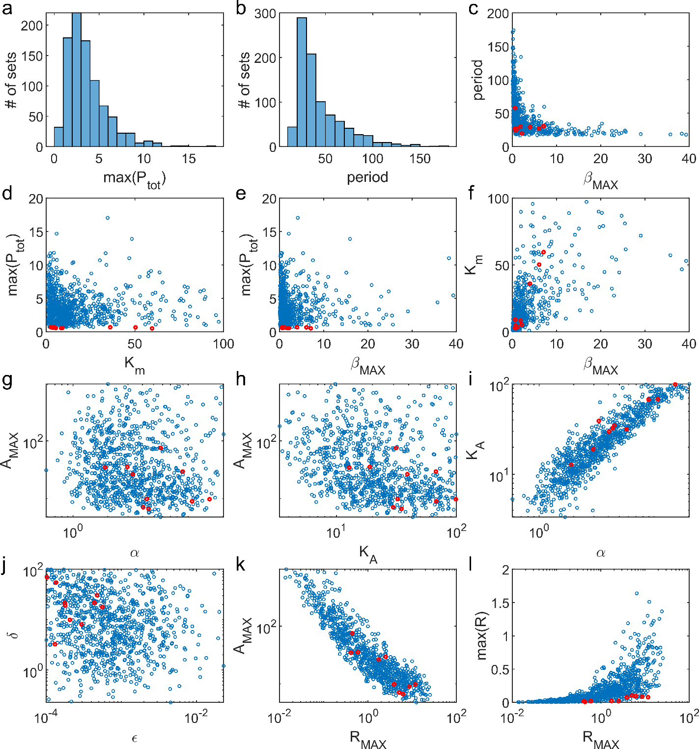

**Figure S5.** **Notable patterns in optimization results for PNF(1M8)**. Blue: 898 parameter sets obtained through optimization are plotted in each panel. Red: top 10 parameter sets (with smallest values of max(*P*tot)).

Main findings:

1. max(*P*tot) = 3.60 ± 2.21 (Figure S5a), Period = 43.9 ± 25.4 (Figure S5b).
2. Period is strongly negatively correlated with *β*max (Figure S5c), as in SNF model(Figure S3c).
3. Low max(*P*tot) still requires low *β*max (Figure S5e), but is less dependent on *K*m (Figure S5d).
4. Like the NNF model, *α* and *A*MAX are no longer correlated (Figure S5g), nor are *A*MAX and *K*A (Figure S5h). But *α* and *K*A are strongly positively correlated (Figure S5i).
5. For most of the optimized parameter sets, the time-scale parameter *δ* > 1 (Figure S5j), and in all cases *ε* << 1 (Figure S5j). Note that *ε* is the ‘background’ rate of *Per* gene transcription when *R*(*t*) = 0. The parameter *ε* was introduced to avoid the trivial steady state, which often prevents the simulation to generate the oscillatory solution.
6. *A*MAX and *R*MAX are strongly negatively correlated (Figure S5k), opposite to the relation between *A*MAX and *V*MAX in the NNF model (Figure S4n). Since BMAL and ROR enhance the expression of each other, this negative relation probably helps stabilize the BMAL level (recall that the best sets for the SNF model have *A*T in a narrow range).
7. Although the parameter *R*MAX and the output max(*R*) are positively correlated as expected, the top sets are associated with max(*R*) << 1 (Figure S5l). Recall that the non-dimensionalized dissociation constant between ROR and the *Bmal* gene is 1. max(*R*) << 1 indicates that robust oscillation is favored by ROR levels far below levels that saturate binding to the *Bmal* gene, presumably by maintaining sensitivity of the auxiliary positive feedback loop.

# Period dependence on fold-changes in *Bmal1* and *Per* expression

Figures S6 and S7 show the dependence of oscillatory period on *Bmal1* expression (*A*T or *A*MAX) and on *Per* expression (*α*), respectively, for L- and M-type models (linear- and Michaelian-degradation of nuclear PER). On each figure we indicate a measure of the relative change in period,

across the range of gene expression, and the absolute change (in hours): h. For the PNF(1M8) model, *T*max becomes very large as *A*MAX and *α* increase well above their WT values, so we limit the increase in gene expression to 2.5 x WT in calculation of Δ and Δ*T*.

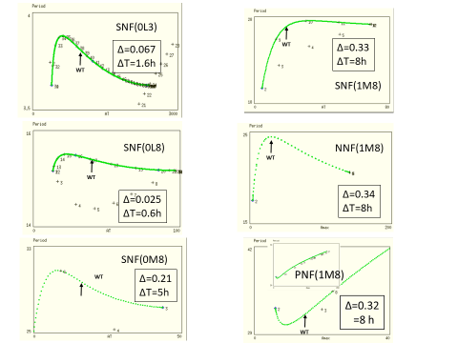

**Figure S6. Dependence of oscillation period on level of expression of *Bmal1*, either *A*T for SNF models or *A*MAX for NNF and PNF models.** Δ*T* is the range of periods observed over the range of gene expression, assuming that the average period over the range = 24 h.

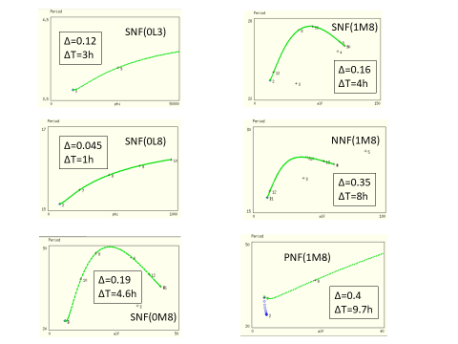

**Figure S7. Dependence of oscillation period on level of expression of *Per*, i.e., parameter *α*.** Δ*T* is the range of periods observed over the range of gene expression, assuming that the average period over the range = 24 h.

# Supplementary references

1. Masters, M. and W.D. Donachie, *Repression and the control of cyclic enzyme synthesis in Bacillus subtilis.* Nature, 1966. **209**(5022): p. 476-9.

2. Goodwin, B.C., *Oscillatory behavior in enzymatic control processes.* Adv Enzyme Regul, 1965. **3**: p. 425-38.

3. Goodwin, B.C., *An entrainment model for timed enzyme syntheses in bacteria.* Nature, 1966. **209**(5022): p. 479-81.

4. Tyson, J.J. and H.G. Othmer, *The Dynamics of Feedback Control Circuits in Biochemical Pathways*, in *Progress in Theoretical Biology*. 1978, Elsevier. p. 1-62.

5. Rapp, P., *Analysis of Biochemical Phase-Shift Oscillators by a Harmonic Balancing Technique.* Journal of Mathematical Biology, 1976. **3**(3-4): p. 203-224.

6. Griffith, J.S., *Mathematics of cellular control processes. I. Negative feedback to one gene.* J Theor Biol, 1968. **20**(2): p. 202-8.

7. Gonze, D. and W. Abou-Jaoude, *The Goodwin model: behind the Hill function.* PLoS One, 2013. **8**(8): p. e69573.

8. Vanselow, K., et al., *Differential effects of PER2 phosphorylation: molecular basis for the human familial advanced sleep phase syndrome (FASPS).* Genes Dev, 2006. **20**(19): p. 2660-72.

9. MacDonald, N., *Time Lags in Biological Models*. 1 ed. Lecture Notes in Biomathematics. Vol. 27. 1978: Springer-Verlag Berlin Heidelberg. VIII, 114.

10. Bliss, R.D., P.R. Painter, and A.G. Marr, *Role of feedback inhibition in stabilizing the classical operon.* J Theor Biol, 1982. **97**(2): p. 177-93.

11. Goldbeter, A., *A model for circadian oscillations in the Drosophila period protein (PER).* Proc. R. Soc. Lond. B., 1995. **261**(1362): p. 319-24.

12. Kurosawa, G. and Y. Iwasa, *Saturation of enzyme kinetics in circadian clock models.* J Biol Rhythms, 2002. **17**(6): p. 568-77.

13. Gonze, D., et al., *Spontaneous synchronization of coupled circadian oscillators.* Biophys J, 2005. **89**(1): p. 120-9.

14. Sato, T.K., et al., *A functional genomics strategy reveals Rora as a component of the mammalian circadian clock.* Neuron, 2004. **43**(4): p. 527-37.

15. Elgar, S., *Relationships involving third moments and bispectra of a harmonic process.* IEEE Transactions on Acoustics, Speech, and Signal Processing, 1987. **35**(12): p. 1725-1726.

16. Koike, N., et al., *Transcriptional architecture and chromatin landscape of the core circadian clock in mammals.* Science, 2012. **338**(6105): p. 349-54.

17. Narumi, R., et al., *Mass spectrometry-based absolute quantification reveals rhythmic variation of mouse circadian clock proteins.* Proc Natl Acad Sci U S A, 2016. **113**(24): p. E3461-E3467.

18. Aryal, R.P., et al., *Macromolecular Assemblies of the Mammalian Circadian Clock.* Mol Cell, 2017. **67**(5): p. 770-782 e6.

19. Narumi, R., et al., *Mass spectrometry-based absolute quantification reveals rhythmic variation of mouse circadian clock proteins.* Proceedings of the National Academy of Sciences of the United States of America, 2016. **113**(24): p. E3461-E3467.